Lab No. | Exception Handling Experiments
1 | Write a Java program to demonstrate exception handling using try and catch by handling division by zero.  class DividebyZeroDemo{  public static void main(String[] args){  try{  int a=10/0;  System.out.println(a);  }  catch(ArithmeticException e){  System.out.println("Cannot divide by zero");  }  }  }  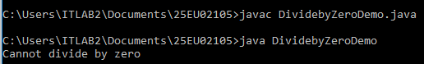
2 | Write a Java program to demonstrate different types of exceptions such as ArithmeticException, ArrayIndexOutOfBoundsException, and NullPointerException.  public class ExceptionDemo {  public static void main(String[] args) {  try {  int result =10/0;  System.out.println("Result: " + result);  } catch (ArithmeticException e) {  System.out.println("Arithmetic Exception");  }  System.out.println();  try {  int[] numbers = {10, 20, 30};  int invalidValue = numbers[5];  System.out.println("Value: " + invalidValue);  } catch (ArrayIndexOutOfBoundsException e) {  System.out.println("Array index out of bound Exception");  }  System.out.println();  try {  String text = null;  int length = text.length();  System.out.println("Length: " + length);  } catch (NullPointerException e) {  System.out.println("Null Pointer Exception");  }  }  }  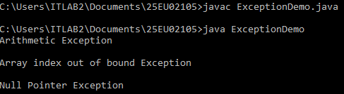
3 | Write a Java program to demonstrate an uncaught exception and observe the default JVM exception message and stack trace.  class UncaughtDemo{  public static void main(String[] args){  int a=10/0;  System.out.println(a);  }  }  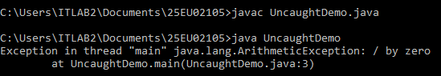
4 | Write a Java program to handle multiple exceptions using multiple catch clauses.  public class MultipleCatchDemo {  public static void main(String[] args) {  try {  int[] numbers = {10, 20, 30};  int result = numbers[1] / 0;  int x=numbers[5];  System.out.println(x);  } catch (ArithmeticException e) {  System.out.println("Cannot divide by zero");  } catch (ArrayIndexOutOfBoundsException e) {  System.out.println("Array index out of bounds");  } catch (Exception e) {  System.out.println("Exception occured");  }  }  }  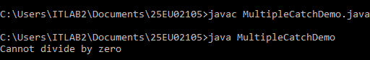
5 | Write a Java program to demonstrate the use of the throw statement to explicitly generate an exception when a given condition is violated.  class ThrowDemo{  public static void main(String[] args){  int age=15;  if(age<18){  throw new ArithmeticException("Not Eligible to vote");  }  System.out.println("Eligible to vote");  }  }  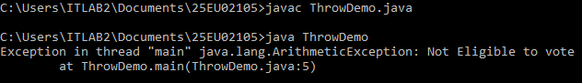
6 | Write a Java program to demonstrate the use of the throws keyword by propagating an exception to the calling method.  import java.io.FileReader;  import java.io.FileNotFoundException;  public class ThrowsDemo {  public static void readFile(String filePath) throws FileNotFoundException {  FileReader file = new FileReader(filePath);  }  public static void main(String[] args) {  try {  readFile("non_existent_file.txt");  } catch (FileNotFoundException e) {  System.out.println(" File not found ");  }  }  }  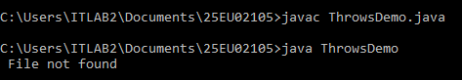
7 | Write a Java program to demonstrate the use of the finally block for executing statements regardless of whether an exception occurs.  class FinallyDemo{  public static void main(String[] args){  try{  int a=10/0;  }  catch(ArithmeticException e){  System.out.println("Cannot divide by zero");  }  finally{  System.out.println("Finally Block Executed");  }  }  }  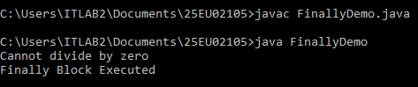
8 | Write a Java program to create a user-defined exception by extending the Exception class.  class AgeException extends Exception {  AgeException(String message) {  super(message);  }  }  class OwnExceptionDemo {  static void checkAge(int age)  throws AgeException {  if (age < 18) {  throw new AgeException(  "Age is less than 18"  );  }  System.out.println("Eligible");  }  public static void main(String[] args) {  try {  checkAge(15);  }  catch (AgeException e) {  System.out.println(e.getMessage());  }  }  }  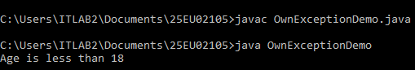
9 | Write a Java program to validate a student's marks and throw a custom exception when the marks are outside the valid range.  class InvalidMarksException extends Exception {  public InvalidMarksException(String message) {  super(message);  }  }  public class StudentMarksValidator {  public static void validateMarks(int marks) throws InvalidMarksException {  if (marks < 0 || marks > 100) {  throw new InvalidMarksException("Invalid marks: " + marks + ". Marks must be between 0 and 100.");  }  System.out.println("Valid marks entered: " + marks);  }  public static void main(String[] args) {  int[] testMarks = {85, -10, 105};  for (int mark : testMarks) {  try {  System.out.print("Validating " + mark + ": ");  validateMarks(mark);  } catch (InvalidMarksException e) {  System.out.println("Validation Error -> " + e.getMessage());  }  }  }  }  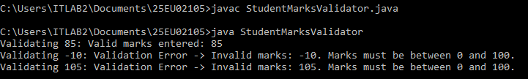
10 | Write a Java program that combines try, multiple catch, throw, throws and finally in a single application.  public class CombinedExceptionDemo {  public static void checkAge(int age) throws Exception {  if (age < 18) {  throw new Exception("Age must be at least 18.");  }  System.out.println("Access granted - Age: " + age);  }  public static void main(String[] args) {  try {  checkAge(15);  }  catch (Exception e) {  System.out.println("Caught Error: " + e.getMessage());  }  finally {  System.out.println("Execution finished.");  }  }  }  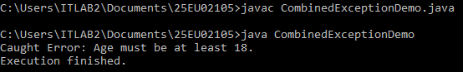

Lab No. | I/O streams: The Byte Streams Experiments
1 | Write a Java program to demonstrate the use of InputStream and OutputStream to read bytes from an input source and write bytes to an output destination.  import java.io.*;  public class IOStreamDemo {  public static void main(String[] args) throws IOException {  InputStream in = System.in;  OutputStream out = System.out;  System.out.println("Enter some text:");  int ch;  while ((ch = in.read()) != '\n') {  out.write(ch);  }  out.flush();  }  }  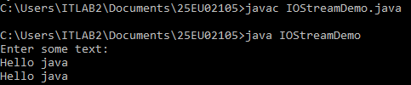
2 | Write a Java program to read the contents of a file byte-by-byte using FileInputStream and display the contents on the console.  import java.io.*;  class ReadFile {  public static void main(String[] args) throws IOException {  FileInputStream fis =  new FileInputStream("input.txt");  int ch;  while ((ch = fis.read()) != -1) {  System.out.print((char) ch);  }  fis.close();  }  }  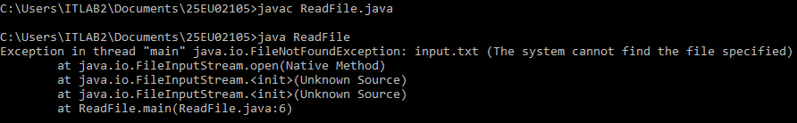
3 | Write a Java program to write data into a file using FileOutputStream and verify the contents of the file.  import java.io.*;  class WriteFile {  public static void main(String[] args) throws IOException {  FileOutputStream fos =  new FileOutputStream("output.txt");  String msg = "Welcome to Java";  fos.write(msg.getBytes());  fos.close();  System.out.println("Data written successfully");  }  }  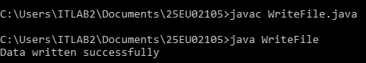
4 | Write a Java program to copy the contents of one file to another file using FileInputStream and FileOutputStream.  import java.io.FileInputStream;  import java.io.FileOutputStream;  import java.io.IOException;  public class CopyFile {  public static void main(String[] args) {  try (FileInputStream fis = new FileInputStream("source.txt");  FileOutputStream fos = new FileOutputStream("destination.txt")) {  int byteData;  while ((byteData = fis.read()) != -1) {  fos.write(byteData);  }  System.out.println("File copied successfully!");  } catch (IOException e) {  System.out.println("Error: " + e.getMessage());  }  }  }  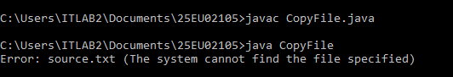
5 | Write a Java program to copy an image from one file to another using byte streams and handle FileNotFoundException and IOException using try-catch-finally.  import java.io.FileInputStream;  import java.io.FileOutputStream;  import java.io.FileNotFoundException;  import java.io.IOException;  public class ImageCopy {  public static void main(String[] args) {  FileInputStream fis = null;  FileOutputStream fos = null;  try {  fis = new FileInputStream("input.png");  fos = new FileOutputStream("output.png");  byte[] buffer = new byte[1024];  int bytesRead;  while ((bytesRead = fis.read(buffer)) != -1) {  fos.write(buffer, 0, bytesRead);  }  System.out.println("Image copied successfully!");  } catch (FileNotFoundException e) {  System.out.println("File not found: " + e.getMessage());  } catch (IOException e) {  System.out.println("I/O error: " + e.getMessage());  } finally {  try {  if (fis != null) fis.close();  if (fos != null) fos.close();  System.out.println("File streams closed.");  } catch (IOException e) {  System.out.println("Error closing streams: " + e.getMessage());  }  }  }  }  

